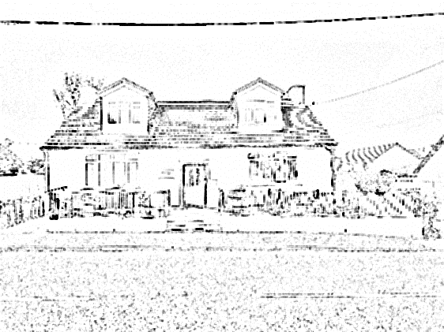 | Blackwood Medical Practice  Dr S Dash (Partner)  Dr C Dash (Partner)

APPOINTMENTS

- Routine appointments can be made for the current and following week (dependant on availability). Booking for a new week opens on a Monday.
- Same day, urgent, appointments are available every day by calling from 8am. We cannot guarantee which doctor you will be appointed to, and availability is completely dependent on demand.
- Appointment reminders can be sent via text, which also gives the facility to cancel if required – please ensure that we have your up to date mobile telephone number.
- Please note that you are a patient of the Practice and not allocated to a specific GP. Every GP and locum GP in the practice has access to the same files and information.

PRESCRIPTION ORDERING

- Requests for repeat prescriptions can be placed in the metal mailbox at the front door of the surgery (covered by 24 hour CCTV) or handed in to the local pharmacy to bring to the surgery on your behalf. If you do not have your pink repeat slip, please put your name, date of birth and the requested mediation on a piece of paper and hand in as above.
- You can also sign up for online prescription ordering – please ask for a registration form from reception.
- Requests for items NOT on repeat should be requested by phone in order that additional information can be obtained for the GP.
- PLEASE ALLOW 48 WORKING HOURS TO PROCESS ALL PRESCRIPTION REQUESTS, OR 72 HOURS FOR ANY HOSPITAL PRESCRIPTIONS.

Blackwood Medical Practice

Dr S Dash (Partner)
Dr C Dash (Partner)

APPOINTMENTS

- Routine appointments can be made for the current and following week (dependant on availability). Booking for a new week opens on a Monday.
- Same day, urgent, appointments are available every day by calling from 8am. We cannot guarantee which doctor you will be appointed to, and availability is completely dependent on demand.
- Appointment reminders can be sent via text, which also gives the facility to cancel if required – please ensure that we have your up to date mobile telephone number.
- Please note that you are a patient of the Practice and not allocated to a specific GP. Every GP and locum GP in the practice has access to the same files and information.

PRESCRIPTION ORDERING

- Requests for repeat prescriptions can be placed in the metal mailbox at the front door of the surgery (covered by 24 hour CCTV) or handed in to the local pharmacy to bring to the surgery on your behalf. If you do not have your pink repeat slip, please put your name, date of birth and the requested mediation on a piece of paper and hand in as above.
- You can also sign up for online prescription ordering – please ask for a registration form from reception.
- Requests for items NOT on repeat should be requested by phone in order that additional information can be obtained for the GP.
- PLEASE ALLOW 48 WORKING HOURS TO PROCESS ALL PRESCRIPTION REQUESTS, OR 72 HOURS FOR ANY HOSPITAL PRESCRIPTIONS.

DID NOT ATTEND POLICY (DNA)

We aim to provide all our patients with the best possible service, and to achieve this we need your cooperation.

If you are unable to keep your appointment, please make every effort to cancel it well in advance (and give at least 2 hours notice) so that it may be offered to someone else. Non-attendance and cancellations at very short notice, even with a good reason, deprives other patients of essential medical services.

REMEMBER THAT YOUR DNA IS ANOTHER PATIENT’S DENIED APPOINTMENT

Failing to attend a booked appointment, or not cancelling it more than 2 hours in advance, will be recorded as a ‘DNA’ (Did Not Attend) in your notes (unless we have reasons to believe that there were exceptional circumstances that caused this non attendance). After 2 failed attendances, you will be notified of this and any further DNA’s may result in you being requested to register at another practice.

ZERO TOLERANCE

Blackwood Medical Practice has a zero tolerance policy in relation to verbal abuse and employee’s rights to be treated in a fair and respectful manner. Should your conduct breach this policy, a warning will be issued or you will be asked to register at another GP practice. Physical abuse or threats will result in immediate removal from the Practice.

125 Carlisle Road, Blackwood, Lanarkshire ML11 9RT
Phone: 01555 893961
Fax: 01555 892192
Website: https:/blackwoodmedicalpractice.gp.scot

DID NOT ATTEND POLICY (DNA)

We aim to provide all our patients with the best possible service, and to achieve this we need your cooperation.

If you are unable to keep your appointment, please make every effort to cancel it well in advance (and give at least 2 hours notice) so that it may be offered to someone else. Non-attendance and cancellations at very short notice, even with a good reason, deprives other patients of essential medical services.

REMEMBER THAT YOUR DNA IS ANOTHER PATIENT’S DENIED APPOINTMENT

Failing to attend a booked appointment, or not cancelling it more than 2 hours in advance, will be recorded as a ‘DNA’ (Did Not Attend) in your notes (unless we have reasons to believe that there were exceptional circumstances that caused this non attendance). After 2 failed attendances, you will be notified of this and any further DNA’s may result in you being requested to register at another practice.

ZERO TOLERANCE

Blackwood Medical Practice has a zero tolerance policy in relation to verbal abuse and employee’s rights to be treated in a fair and respectful manner. Should your conduct breach this policy, a warning will be issued or you will be asked to register at another GP practice. Physical abuse or threats will result in immediate removal from the Practice.

125 Carlisle Road, Blackwood, Lanarkshire ML11 9RT
Phone: 01555 893961
Fax: 01555 892192
Website: https:/blackwoodmedicalpractice.gp.scot

